**Project Report**

**Software Engineering**



**Course: CSE327**

**Section: 6**

**Faculty:** Sarnali Basak (SLB)

**Submission Date:** 10th June 2023

**Group Information:**

Group Members:

|  |  |
| --- | --- |
| **Member Name** | **ID Number** |
| Md. Nafiz Al Mahmud | 2012241042 |
| Asif Rahman | 2012691042 |
| Mia Mahmudul Hoque Shaon | 2014314042 |
| MD Nazmul Islam Srabon | 2021227042 |

**Project Information:**

**Project Name:** জীবন যুদ্ধ , an E-Learning Platform

**GitHub Link:** <https://github.com/asifrahman18/cse327Project>

**Updates Based on Faculty’s Suggestions**

|  |  |  |  |  |
| --- | --- | --- | --- | --- |
| **No.** | **Faculty Suggestion** | **Updates** | **Additional Info** | **Page No** |
| 1 | **Add buttons** in place of input boxes | Completed |  | 16, 19, 23, 24, 26, 28, 29. 32, 33, 34 |
| 2 | Add a **reject button** for admin during teacher verification | Completed | When the admin rejects any verification application, that teacher account gets deleted from the database. However, the teacher will be able to apply again | 16 |
| 3 | Add a **list of enrolled students** for teacher to see | Completed |  | 20, 23, 24 |
| 4 | Add a **remove student** button for teacher for their courses | Completed |  | 24 |
| 5 | Add **upload assignment** option for teacher | Completed | Teachers can select the type of material like lecture or assignment before uploading | 21 |
| 6 | Add **view assignment** option for student | Completed | Students can see the type of material form course profile and view assignment from there | 29 |
| 7 | Add user **registration time** | Not Completed |  |  |
| 8 | Add student **enrollment time** | Not Completed |  |  |

We were suggested to make some updates to our project. The above table contains the list of those changes. We tried to do all the tasks but we couldn’t finish a couple of them. In the above table, we have mentioned the updates which we completed along with the ones which we couldn’t.

**Introduction:**

Our project is a web-based E-learning platform called জীবন যুদ্ধ. It is designed to meet the needs of educational institutions, teachers, and students alike. Whether you are a teacher, or a student, our platform offers a range of features to streamline the management and learning process.

There are three types of users: Admin, Teacher, and Student.

For teachers, our website provides tools for creating and organizing courses, and managing assignments and assessments. Teachers can easily track student enrollment.

Students benefit from a user-friendly interface where they can access their course materials and assignments. Our website fosters a dynamic and interactive learning environment, enabling students to engage with course content and enhance their educational experience.

Admin have access to a comprehensive users list, allowing them to monitor the enrollment of students and the creation of courses of teachers.

**Vision Statement:**

জীবন যুদ্ধ is an online web application for students and teachers who want a simple but effective education platform. Unlike currently available platforms, জীবন যুদ্ধ is a free platform. It will provide a simple, intuitive interface that will also make sure that the teachers are verified and make study much more comfortable.

**Features:**

**Student:**

* Registration and login
* Enroll and Drop
* View materials of enrolled course
* Edit profile

**Teacher:**

* Registration and login
* Upload course material
* View Course list
* View all Student of their respective course
* Remove a particular student from a course
* Edit Profile

**Admin:**

* Login
* Verify teachers (reject/accept)
* Remove user (teacher, student)
* Remove Course
* Manage the whole system

**Major Functional Requirements:**

1. Students must register to enroll
2. Teachers must complete the verification process to register
3. The student must be able to search for courses
4. The system must allow the students to see the teacher’s profile.
5. Teachers should be able to publish their course materials
6. The system must allow the admin to remove students and teachers account. Also irrelevant courses.

**Non-Functional Requirements:**

1. The users can request to remember their passwords.
2. Forgetful users can reset their password.
3. The website will keep track of the total number of teachers, students and courses. Also, display the count in the homepage.
4. Students can also search for courses by category from their respective profile page.

**Diagrams:**

**1. Use Case Diagram:**

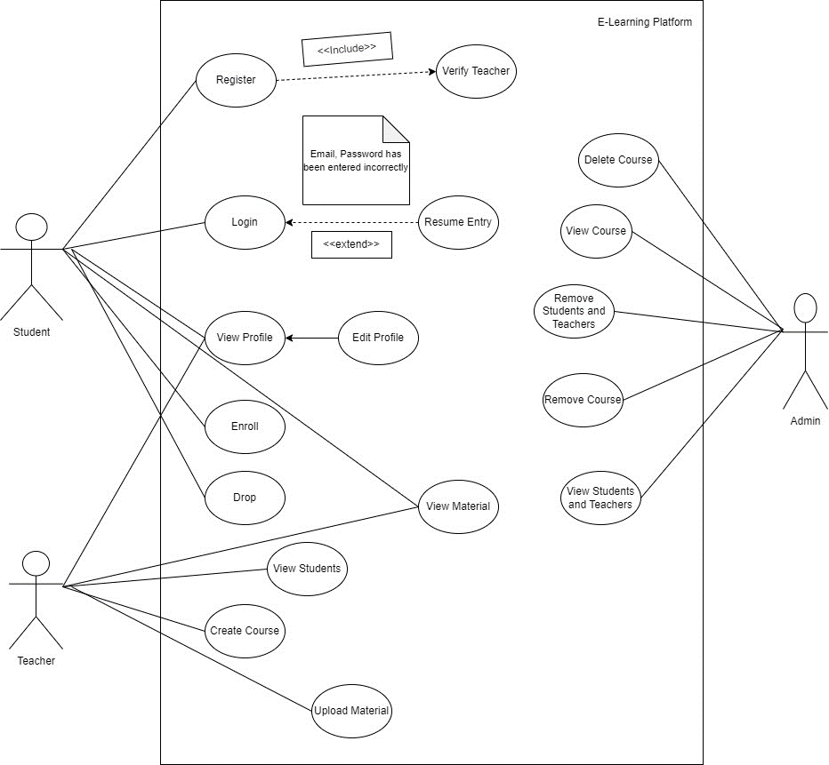

**2. UML Diagram:**

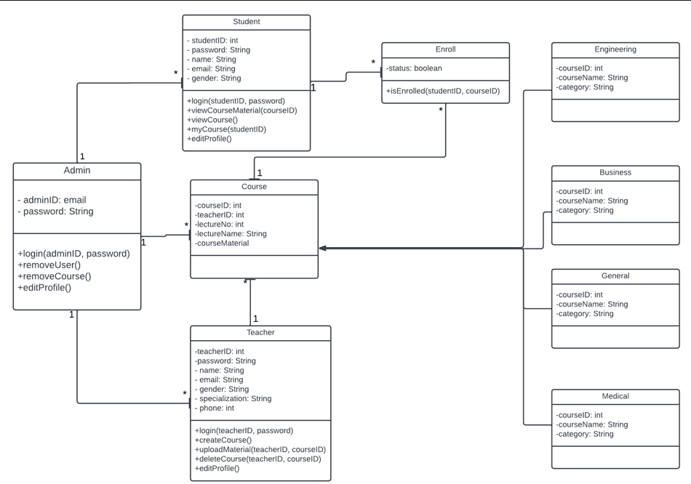

**3. Sequence Diagram:**

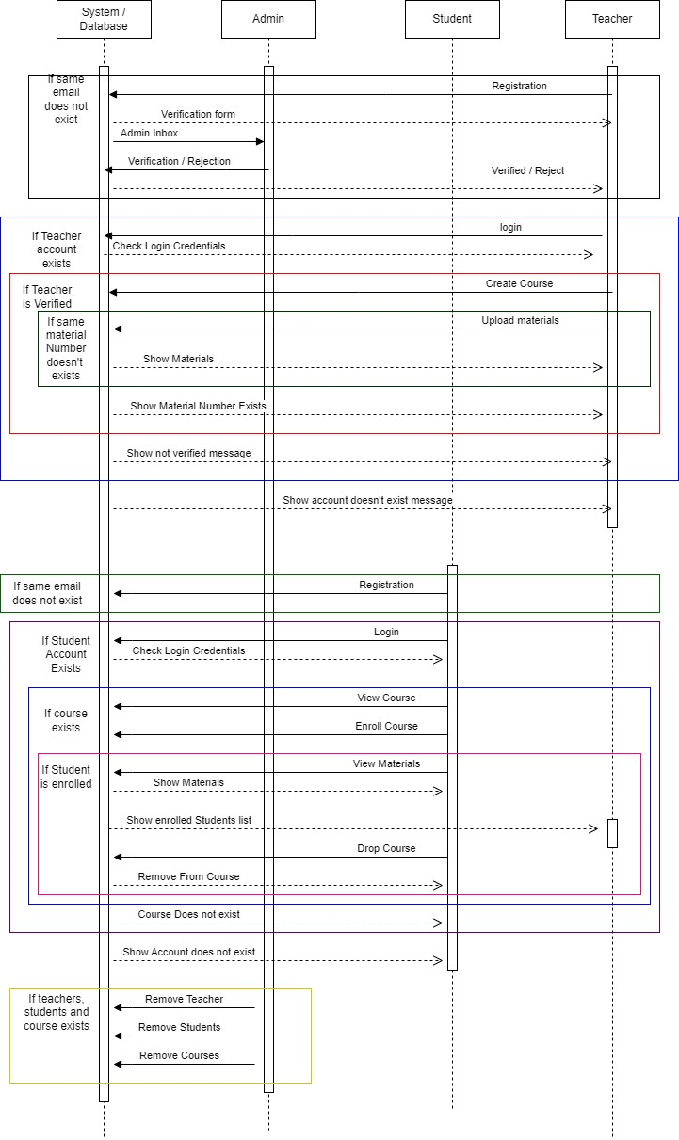

**Use Cases:**

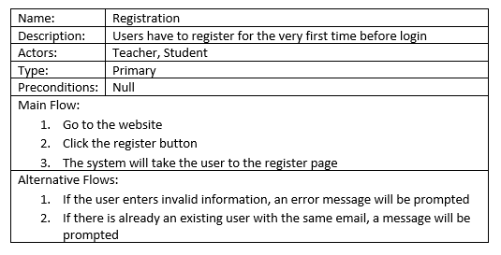

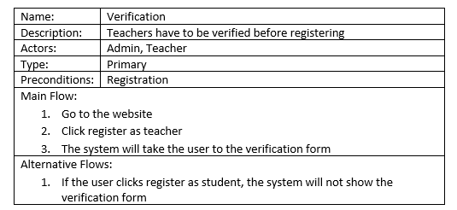

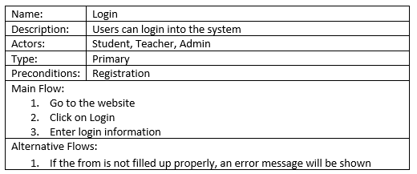

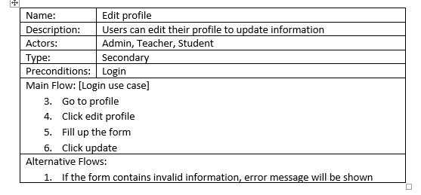

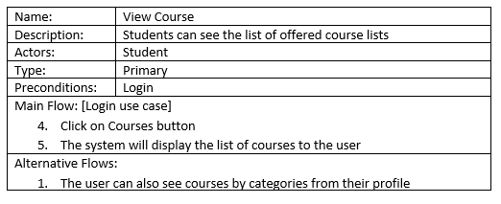

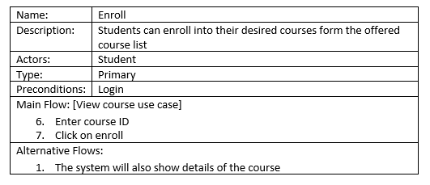

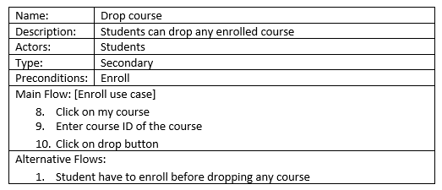

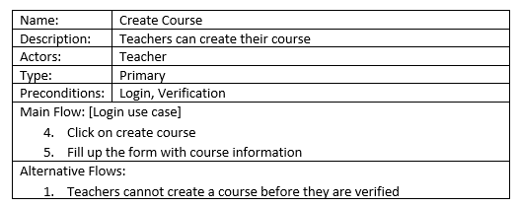

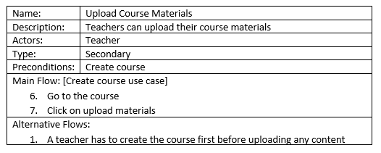

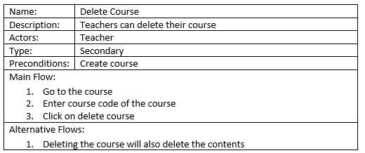

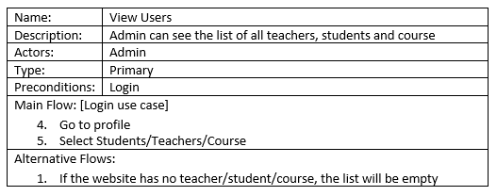

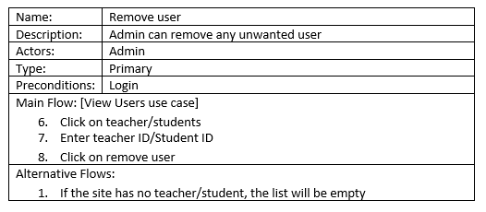

**Implementation:**

1. **Database**

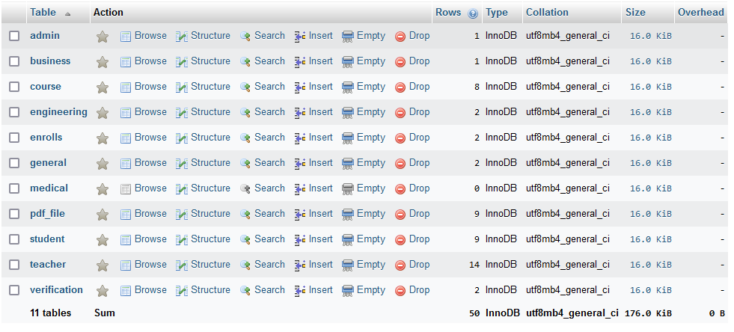

1. **Interface**



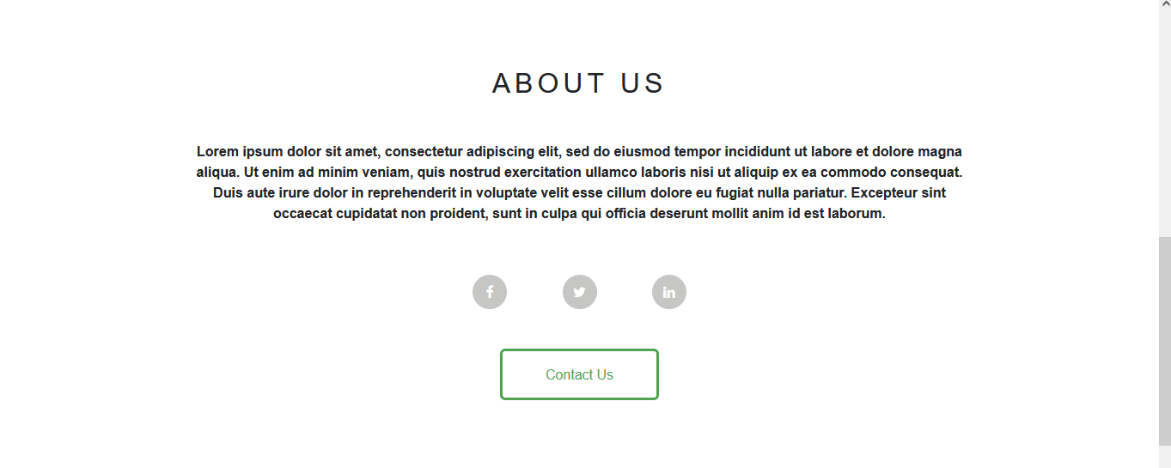

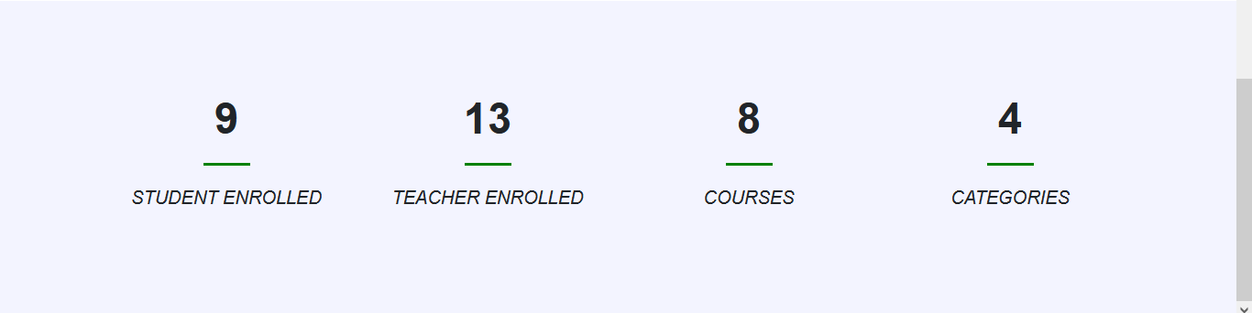

**Home Page**

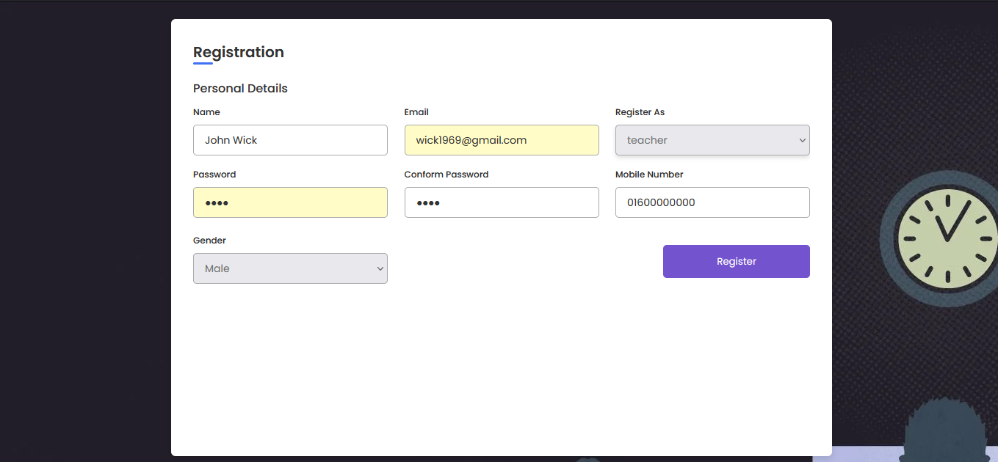

**Registration Page (Teacher)**

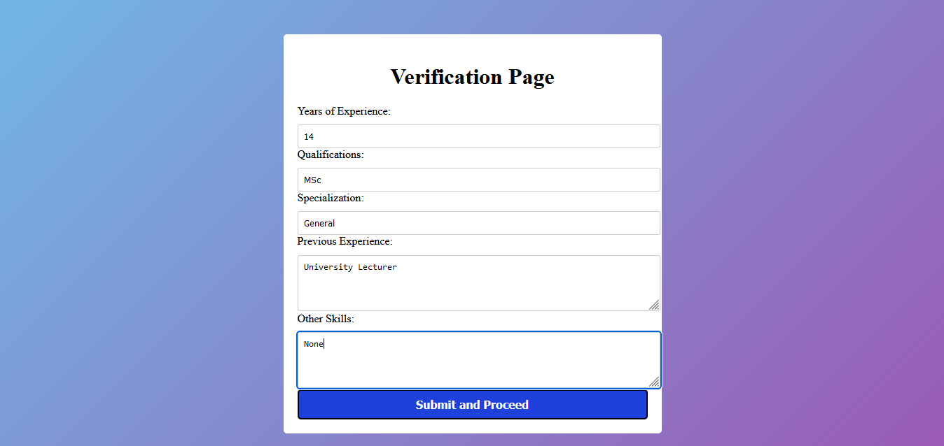

**Teacher’s Verification Page**

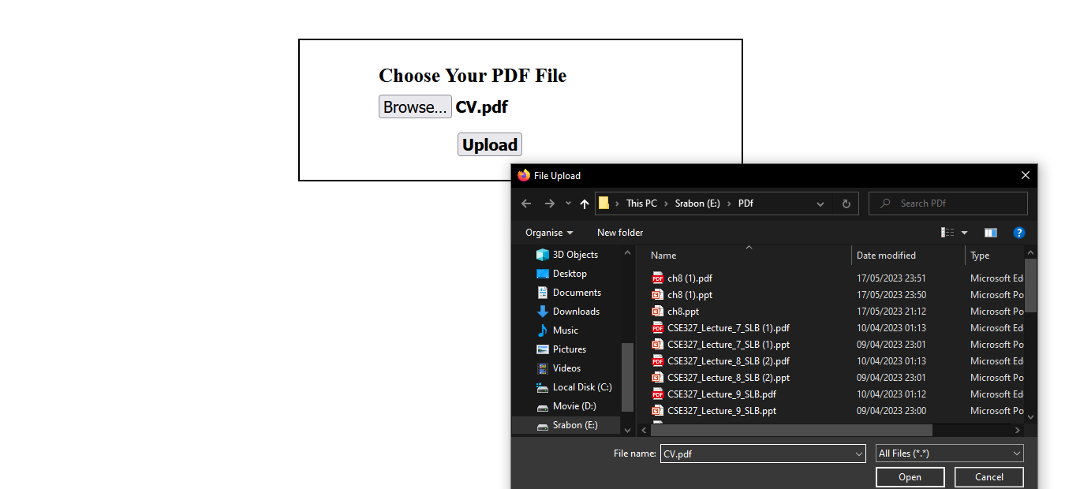

**Upload Teacher’s Verification Document**

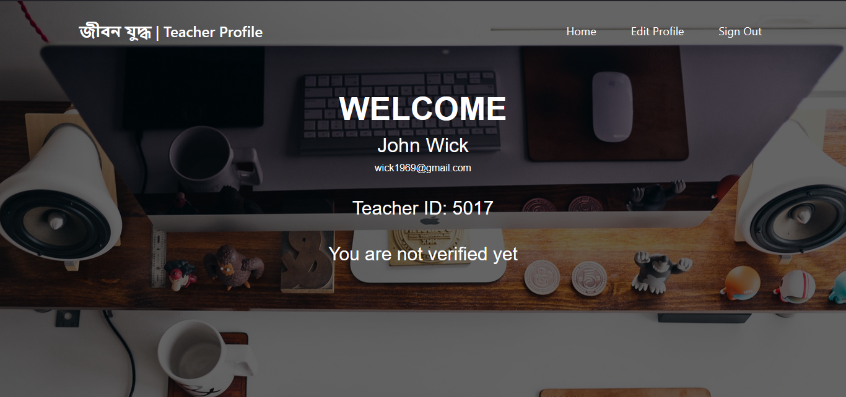

**Teacher’s Profile (pre-verification)**

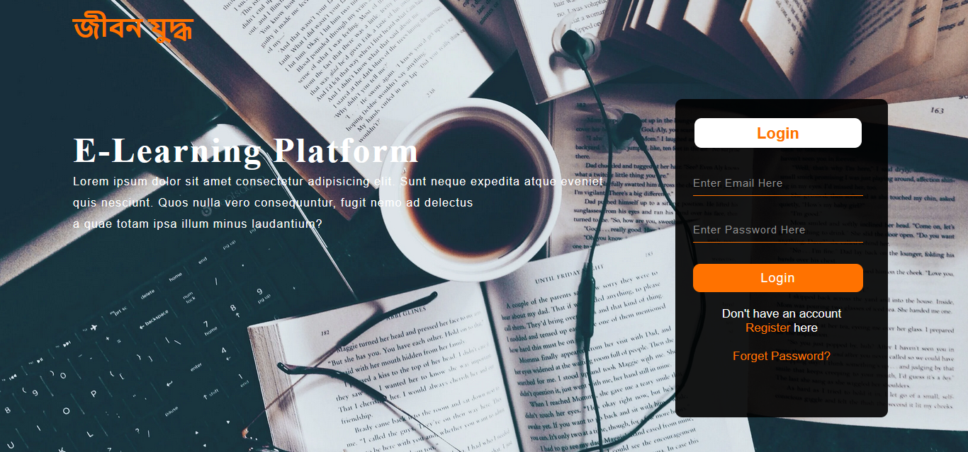

**Login Page, for all users (Student, Teacher & Admin)**



**Admin Profile**

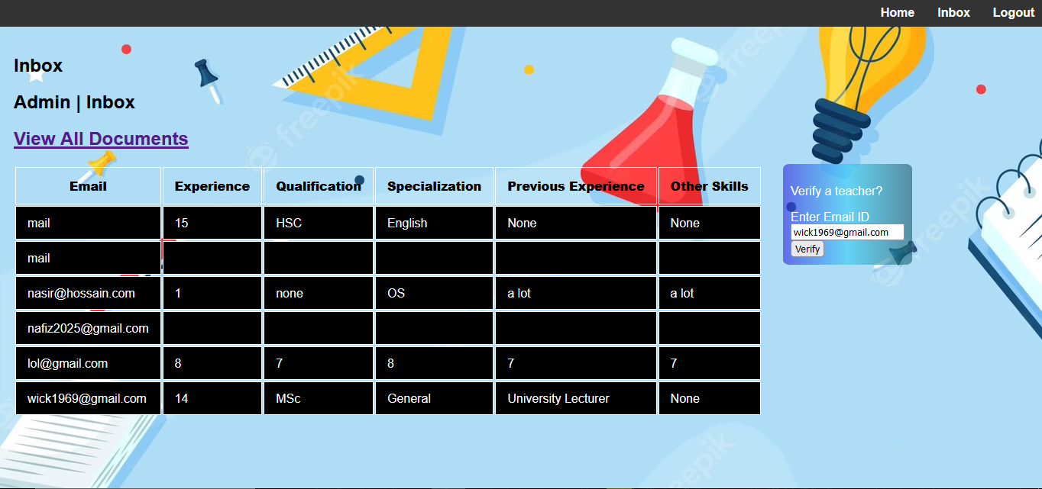

**Admin inbox (before)**

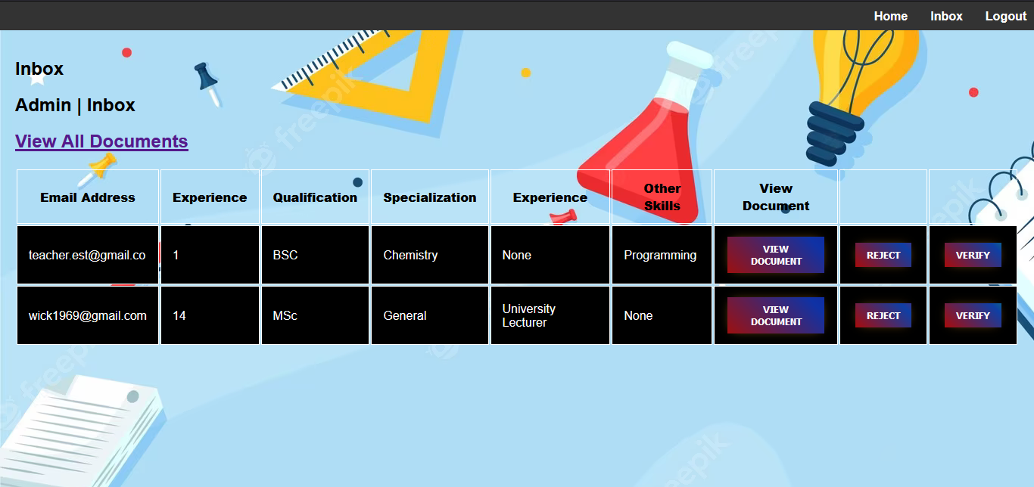

**Admin Inbox (Update 1, 2)**

Here, if the admin clicks on **view Document,** he/she would be able to view individual documents. Whereas, if he/she clicks **View All Documents** then he/she would view the entire document page.

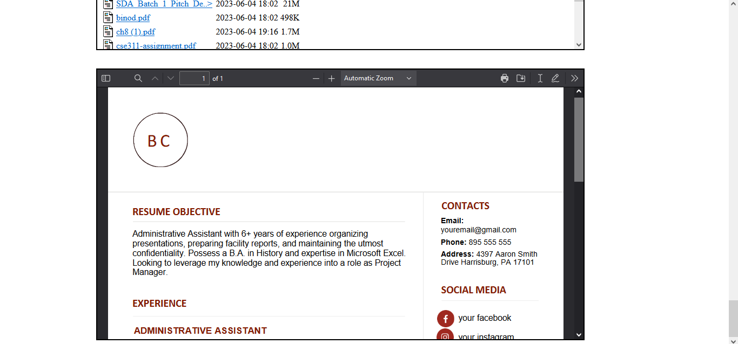

**View Document Page, for admin**



**Teacher’s Profile (post-verification)**

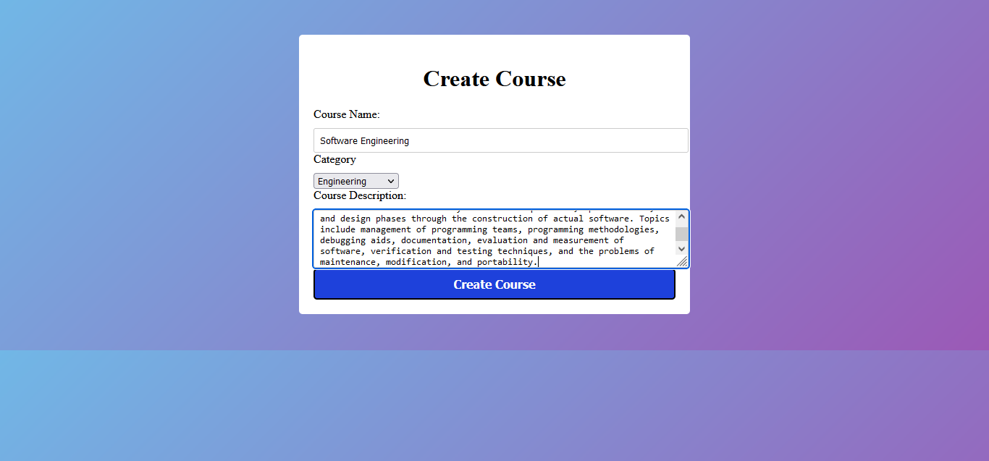

**Create Course Page**

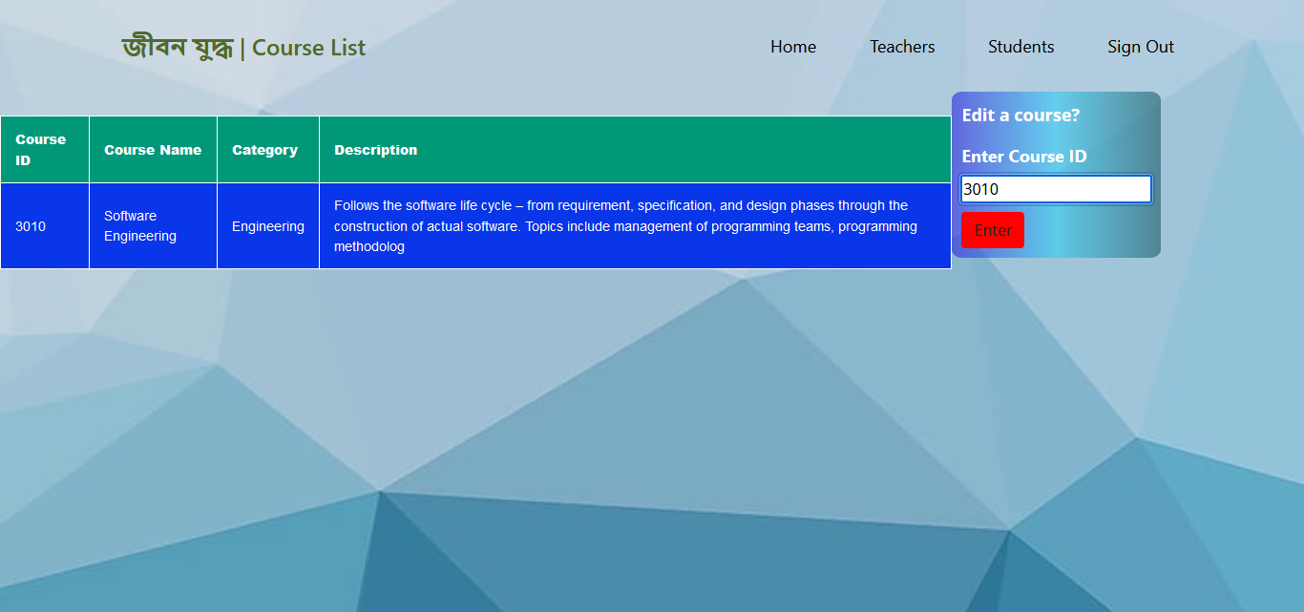

**My Courses Page, for Teacher (Before)**

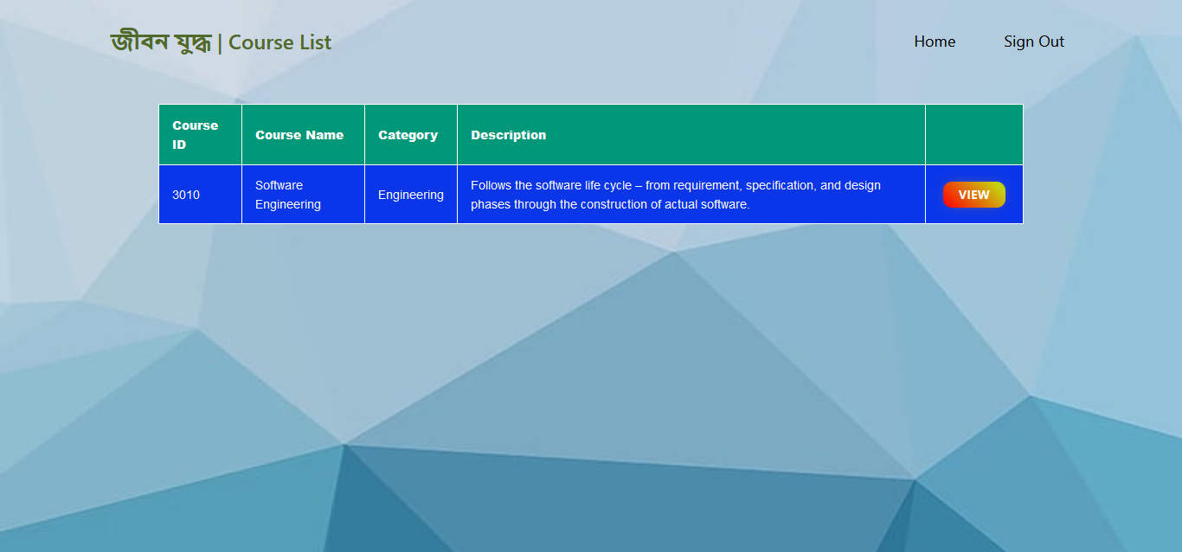

**My Courses Page, for Teacher (Update 1)**

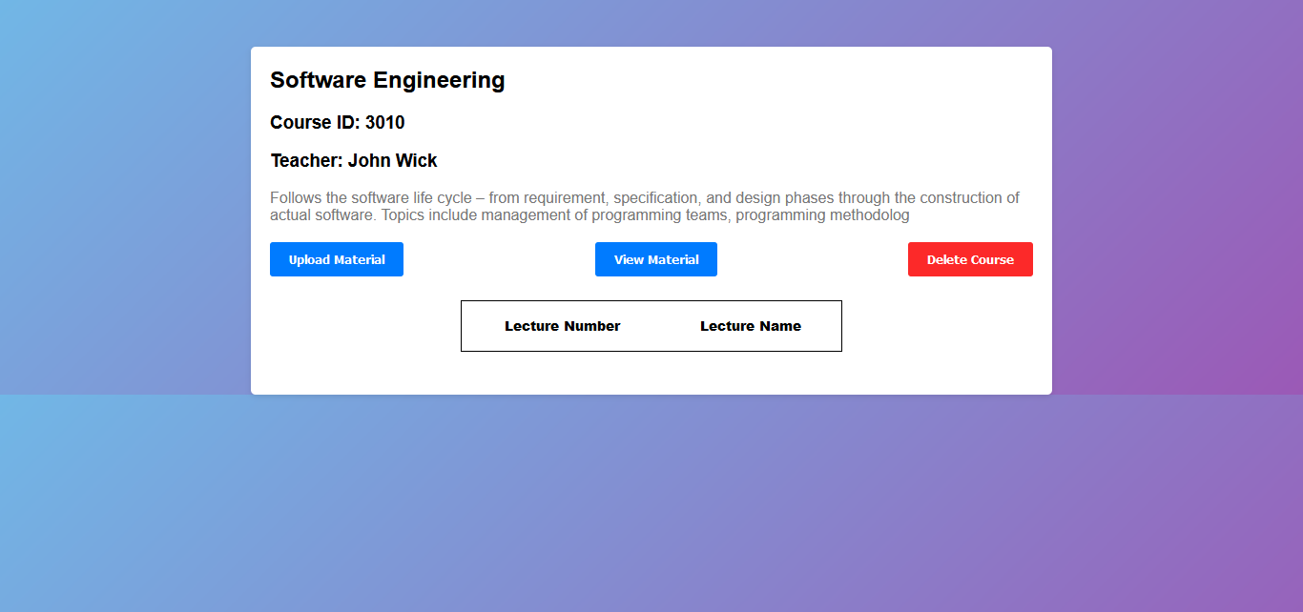

**View Course, for Teacher (Before)**

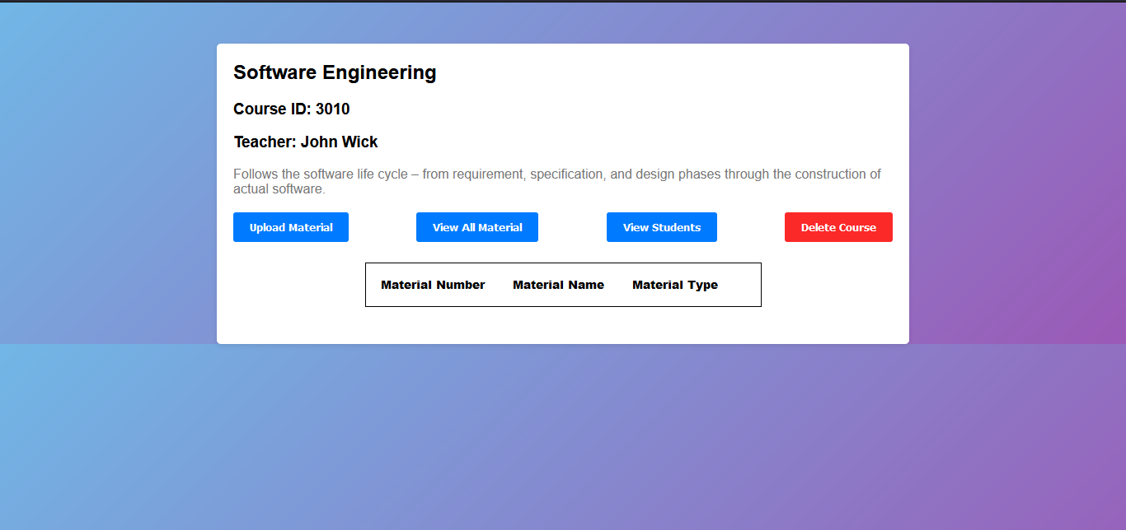

**View Course, for Teacher (Update 3)**

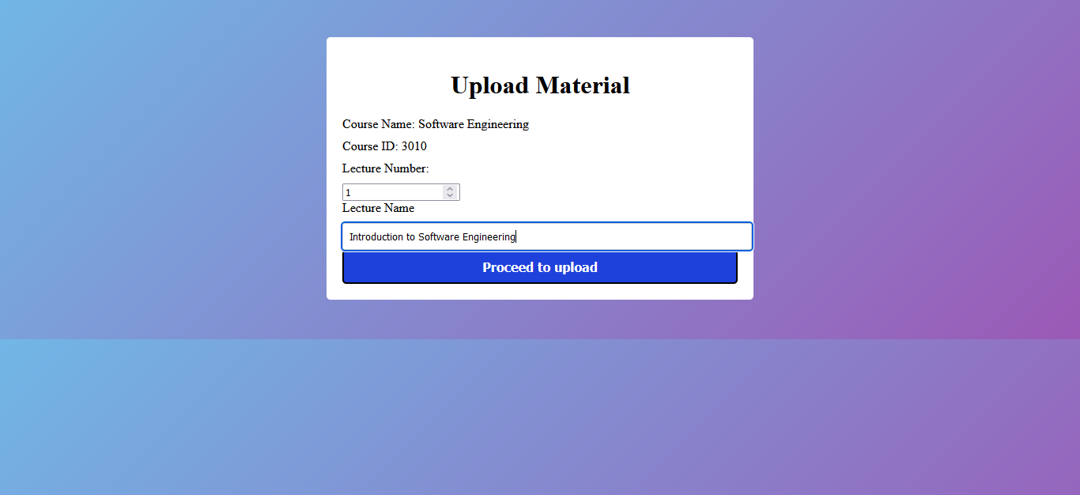

**Upload Material, for Teacher (Before)**

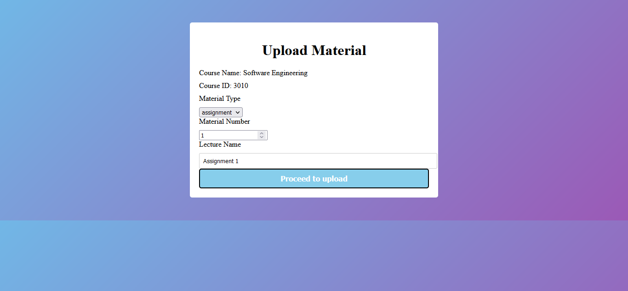

**Upload Material, for Teacher (Update 5)**

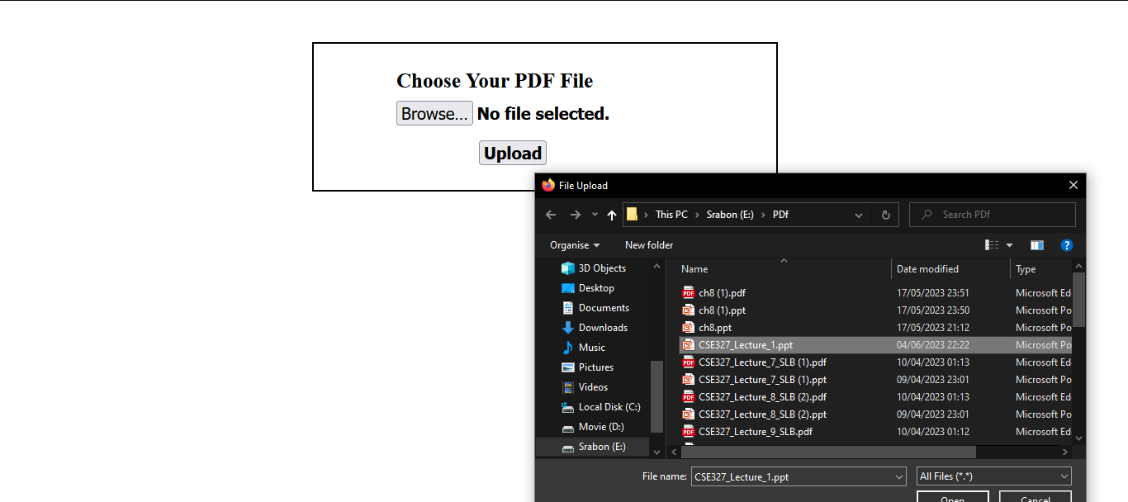

**Choose Material, for Teacher**

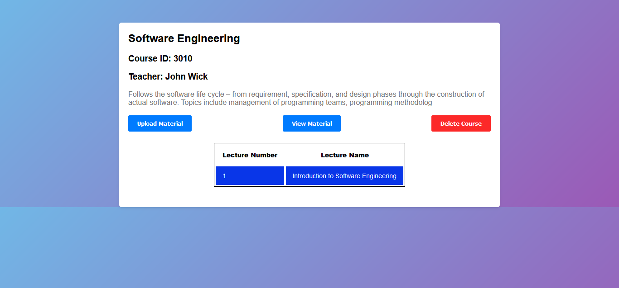

**Course Profile Page, for Teacher (Before)**

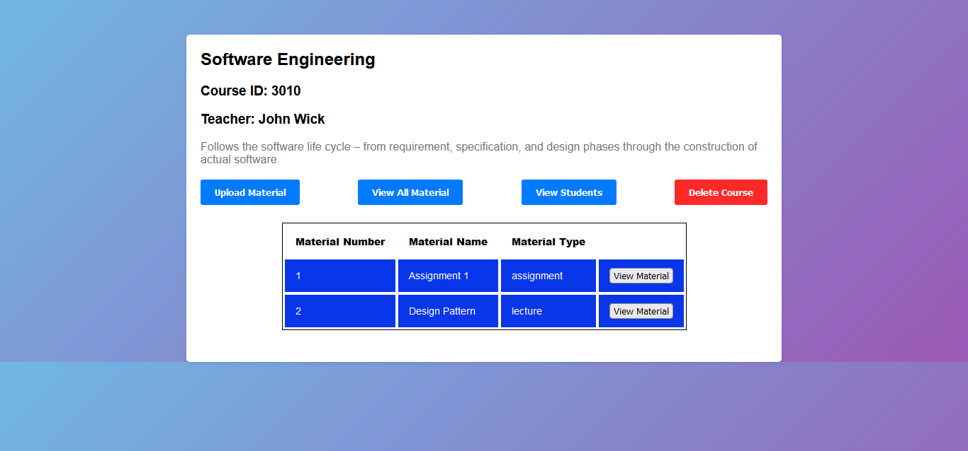

**Course Profile Page, for Teacher (Update 1, 3)**

Here, if the Teacher clicks on **view material** he/she would be able to view individual materials. Whereas, if he/she clicks **View all material** then he/she would view the entire material page.

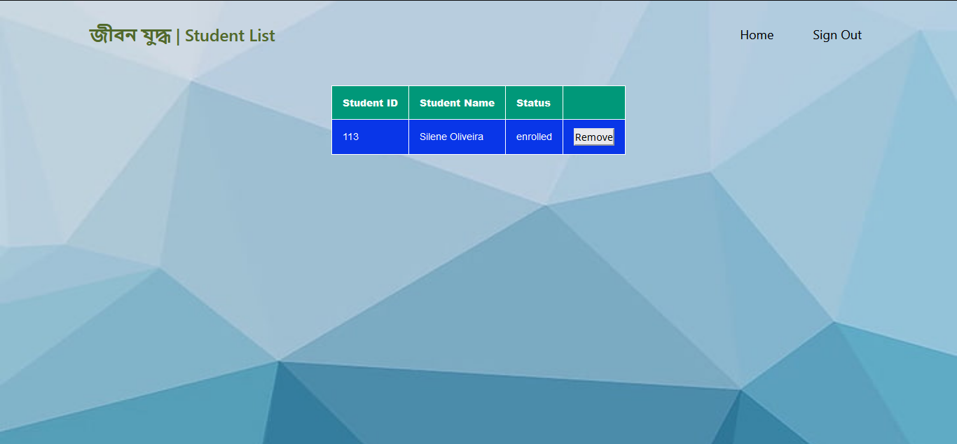

**Enrolled Student List, for Teacher (Update 1, 3, 4)**

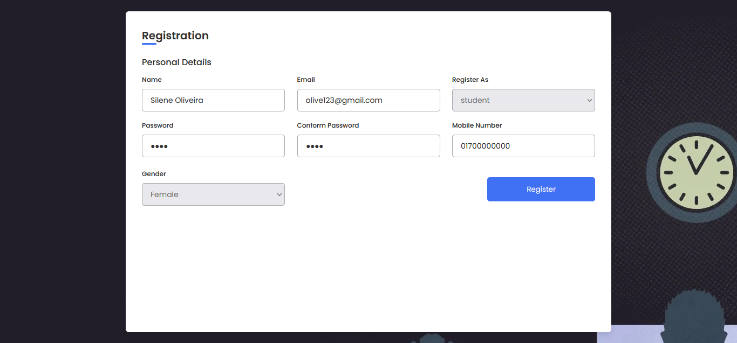

**Student Registration Page**

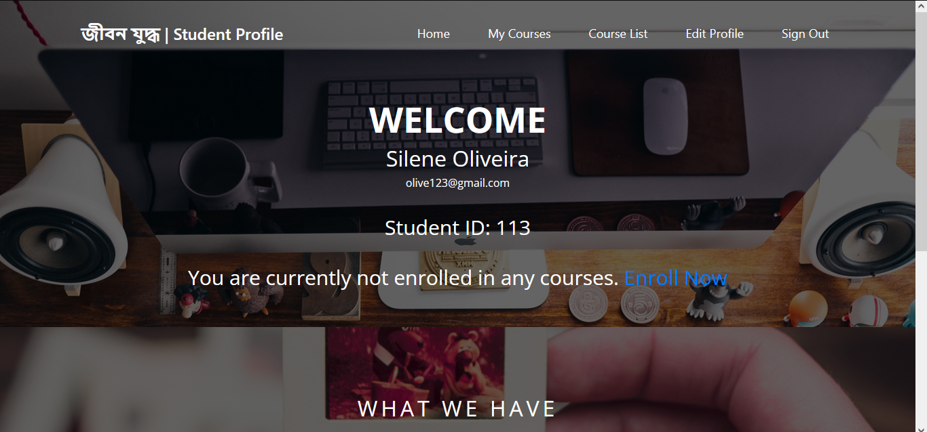



**Student Profile (not enrolled yet)**

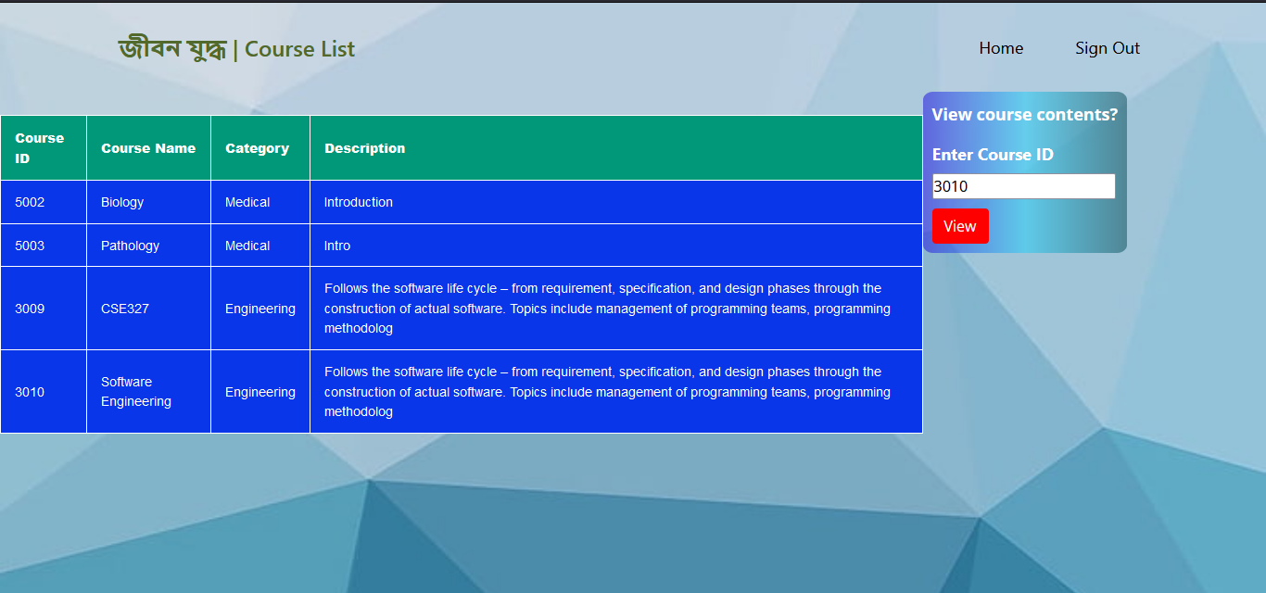

**Course List, for Student (Before)**

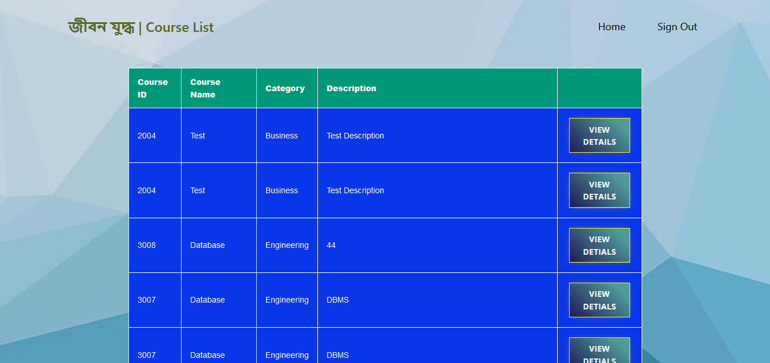

**Course List, for Student (Update 1)**

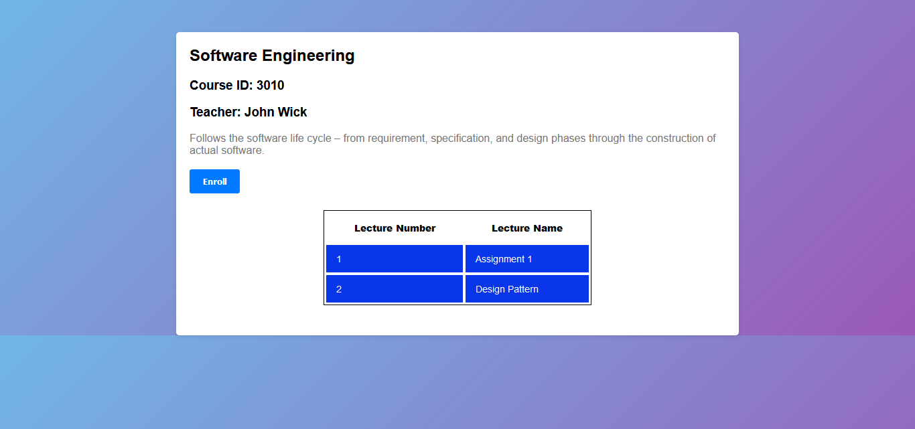

**Enroll Page, for Student**

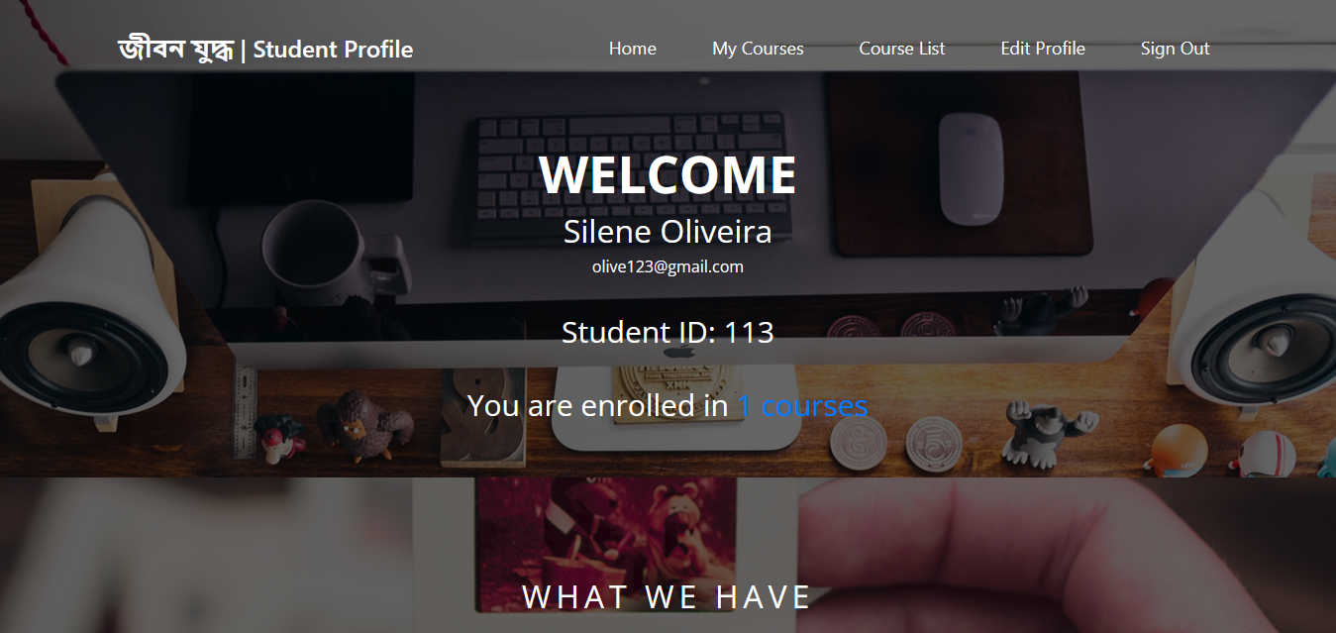

**Student Profile (Post-Enrollment)**

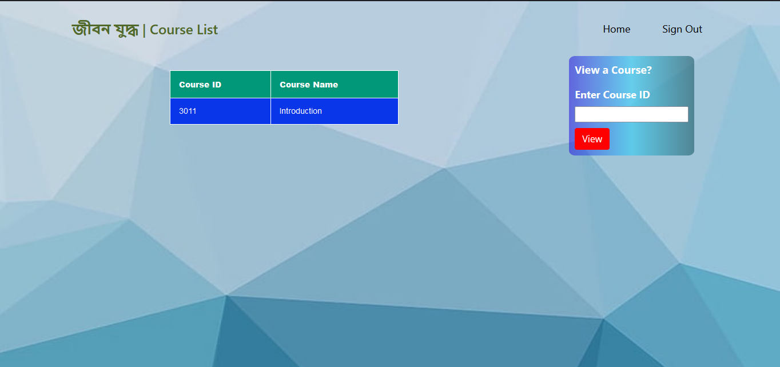

**My Courses Page, for Student (Before)**

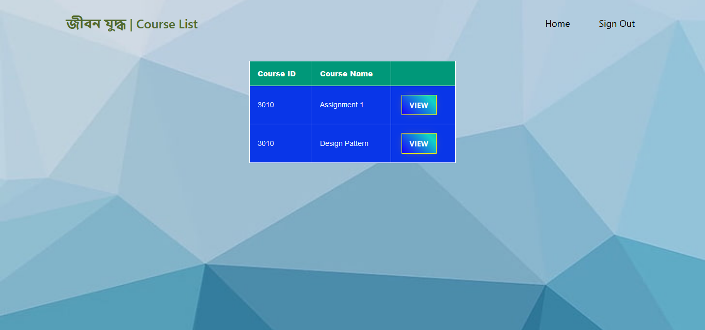

**My Courses Page, for Student (Update 1)**

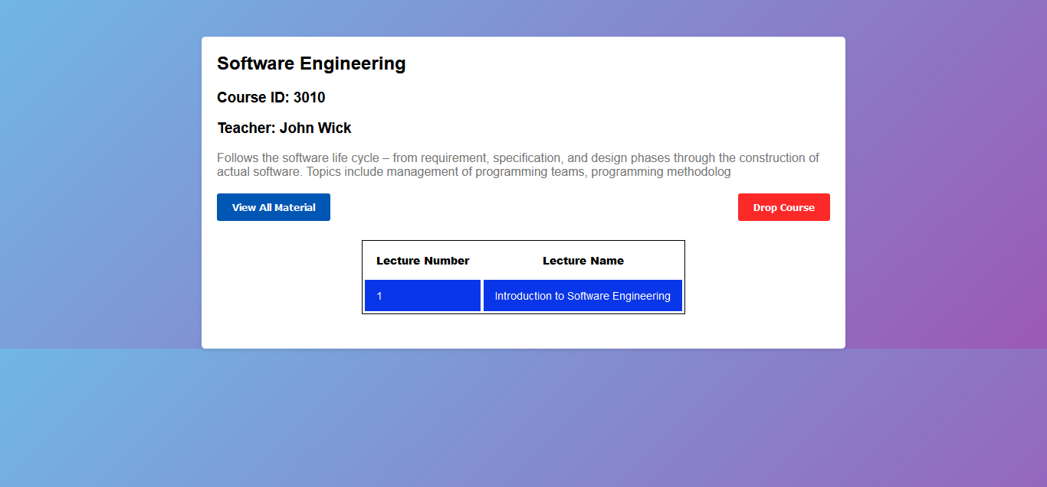

**View Course, for Student (Before)**

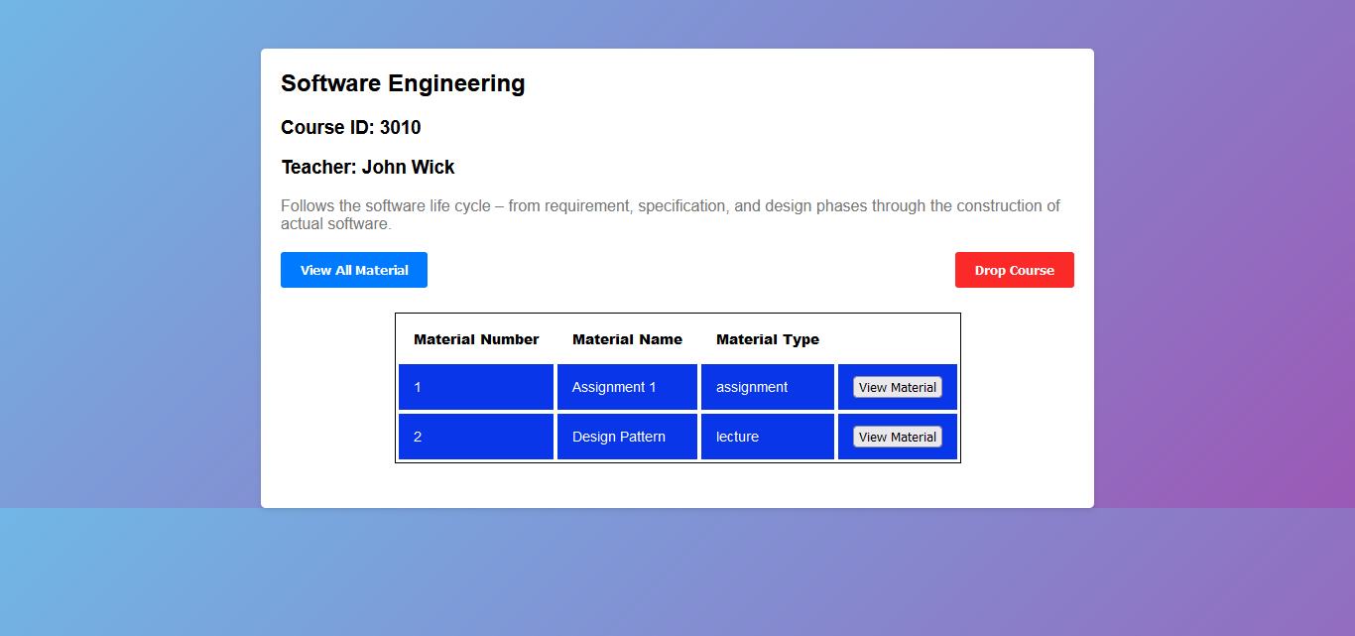

**View Course, for Student (Updated 1, 6)**

Here, if the student clicks on **view material** he/she would be able to view individual materials. Whereas, if he/she clicks **View all material** then he/she would view the entire material page.

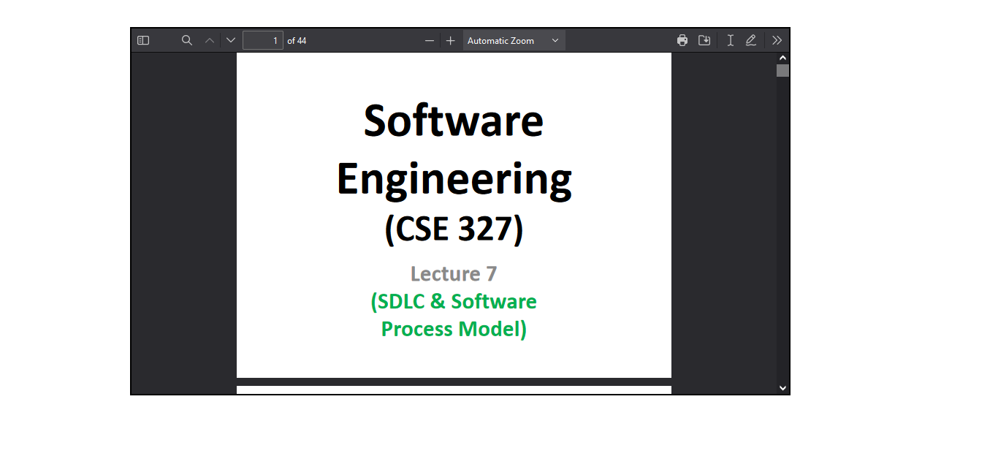

**View Material Page, for Student**

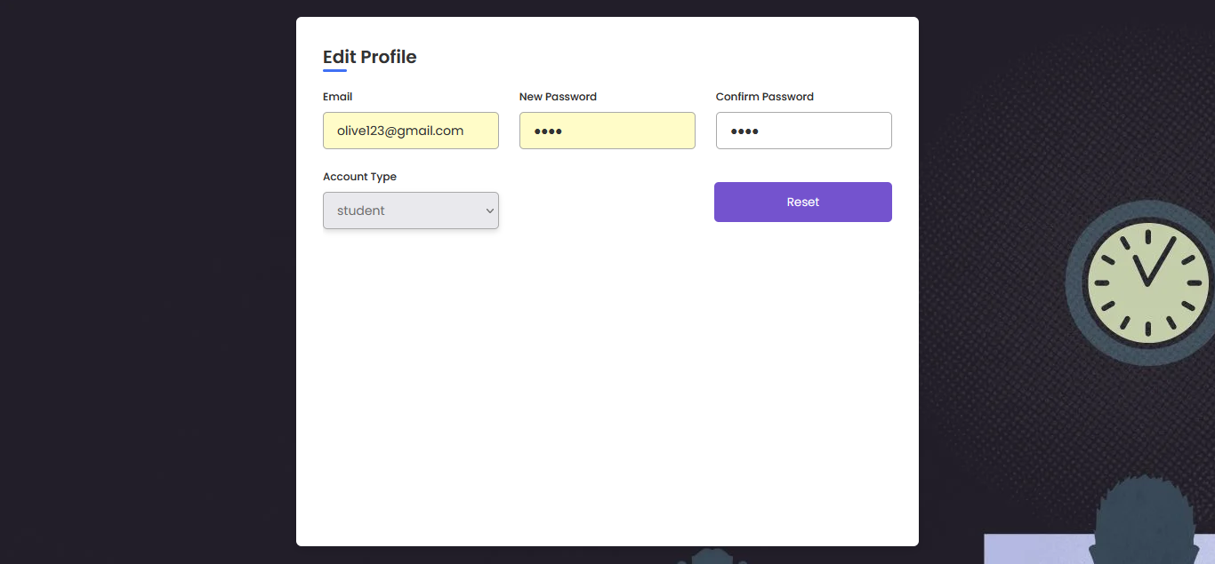

**Edit Profile Page, for both Student & Teacher**



**Profile Page, for Admin**

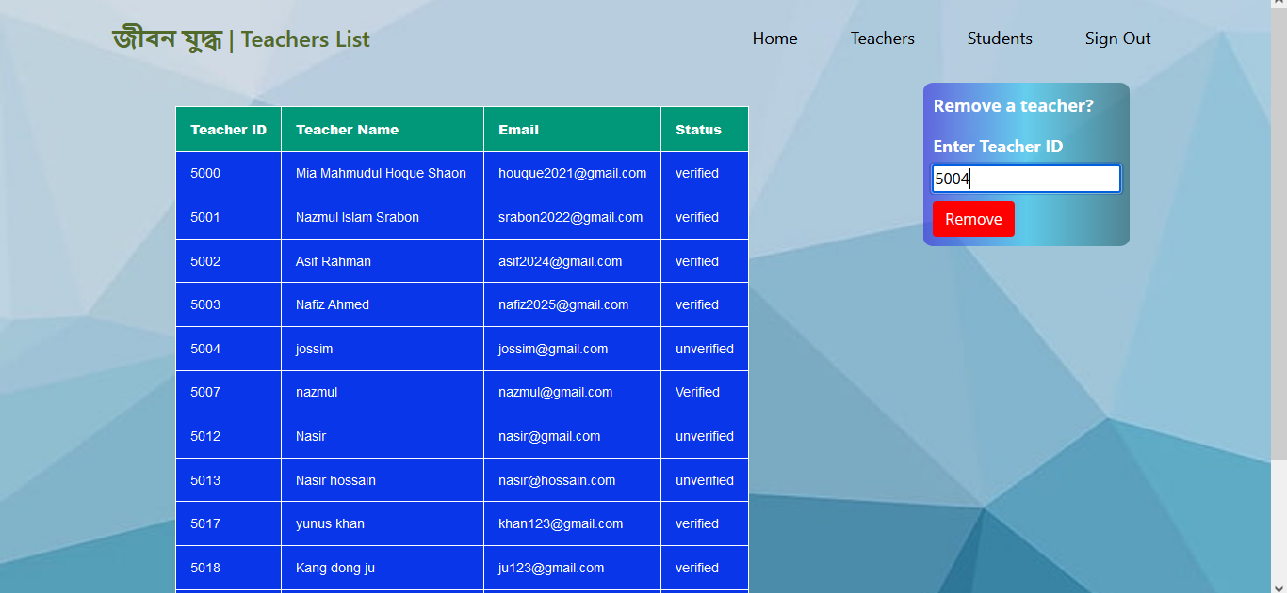

**Teachers List, for Admin (Before)**

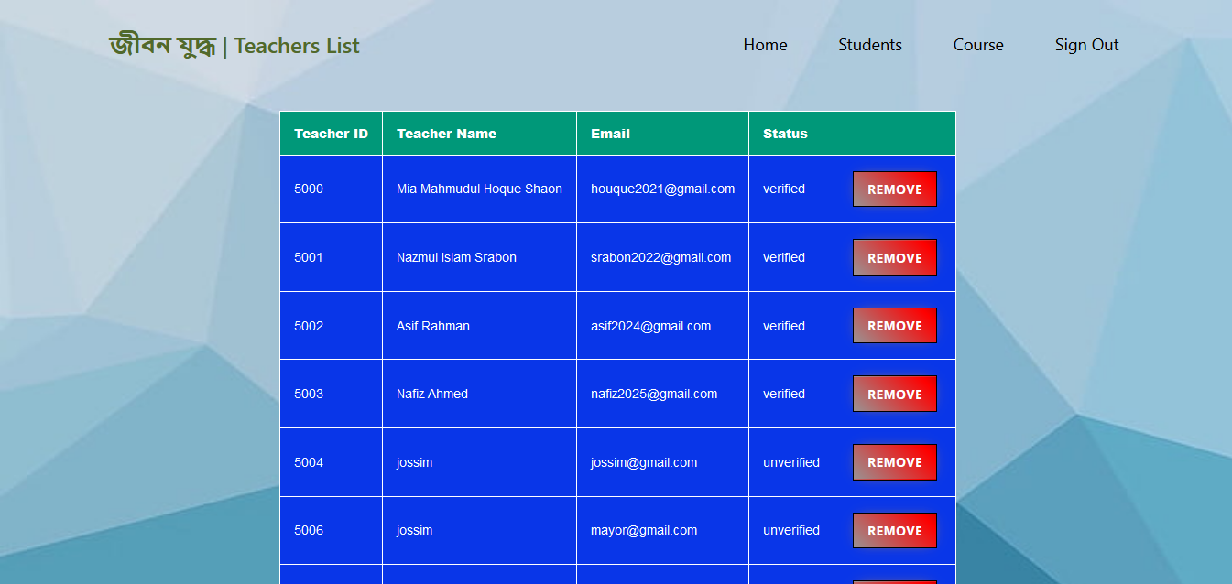

**Teacher’s List, for Admin (Update 1)**

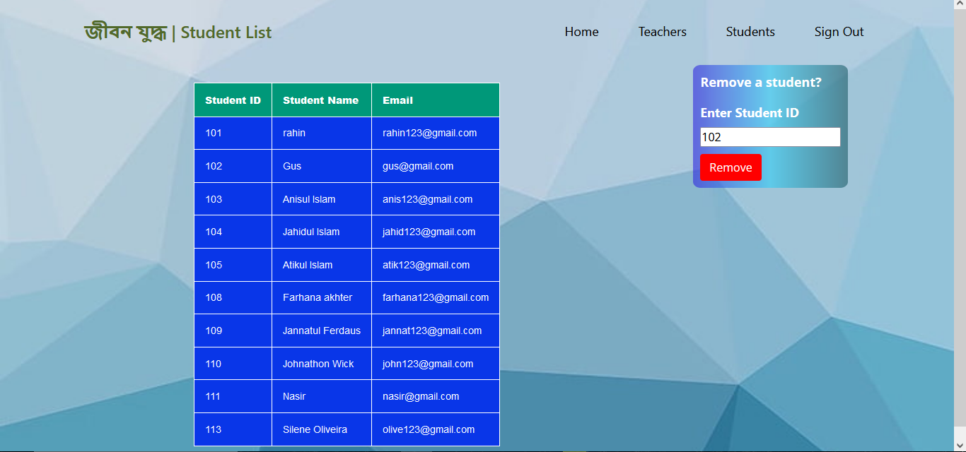

**Student List, for Admin (Before)**

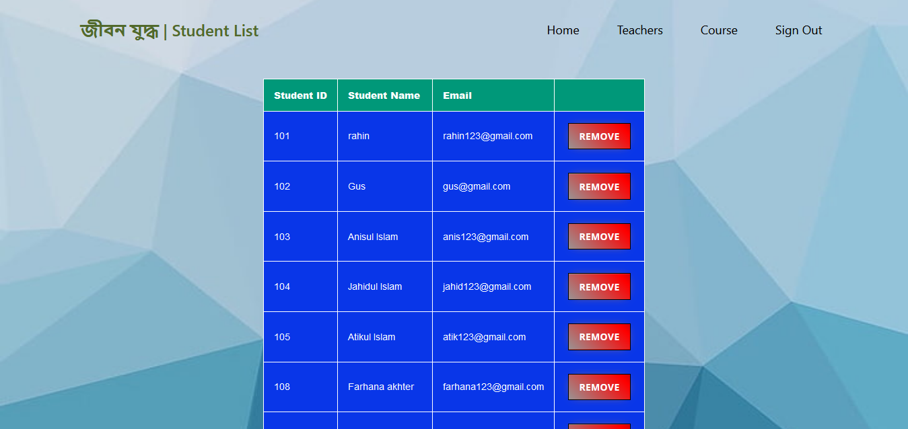

**Student List, for Admin (Update 1)**

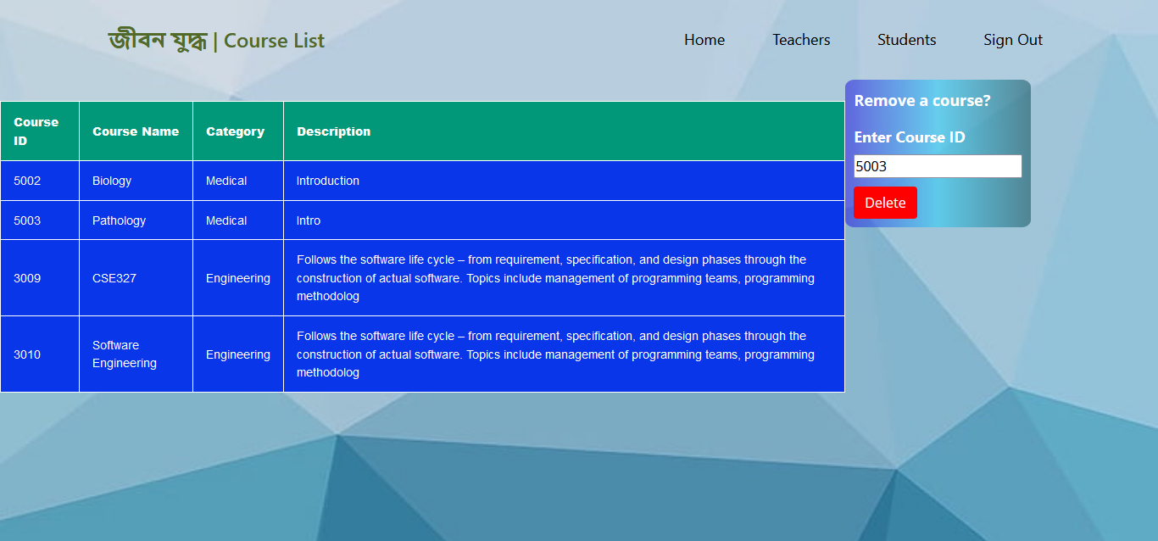

**Course List, for student (Before)**

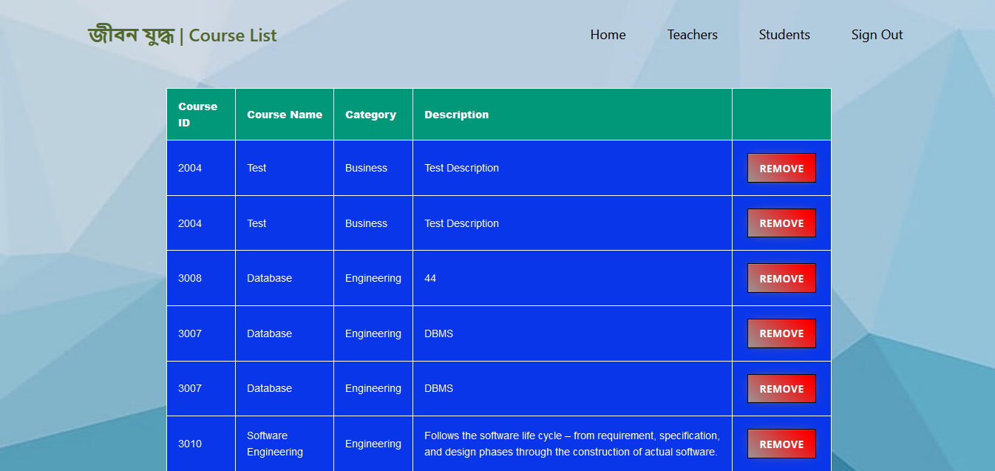

**Course List, for Admin (Update 1)**